Market data from 330 of Big Mountain Resort’s 330 closest competitors across the US suggests that

the current day pass ticket price is underpriced.

The company can optimize ticket price, and therefore profitability, based on the model presented in

this study, where it is shown that the current market will bear price increases from the current $81 to

$95.87 (+ $14.87)

Out of 32 features the top features that support the price hike are

1. Runs
2. Vertical Drops
3. Fast Quads
4. Snow Making_ac

We can close first 5 runs and not have a significant impact, however the operations cost savings are not visible. This scenario 1 and scenario 2 increases support for ticket price by $1.99. Which can provide a revenue increase of $3.4Million as each of the 350K visitors buy 5 tickets.

We should look at the open days into separate categories.

1. Week day prices

2. Weekend prices

We should compare the weekday prices separately from weekend prices. It doesn't make sense to only hike the weekend prices. We should also look at the historic data and find the days with the least attendance to the park during the season and sell tickets at a discounted price to incentivize the customers to visit.

Data point that is missing in this analysis is per day operations cost.

From an operational perspective, I would recommend doing analysis of historic sales compared to per day cost and per day ticket sales to see the low volume days prices can be optimized to lure visitors to the park.

Project Context:

The project was setup so we could get a hands-on training in applying the data science project.

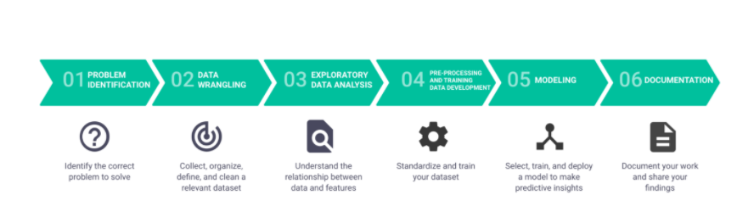

We were provided data in CVS file format and ipython notebooks (Jupyter Notebooks) with step by step instructions to solve the above capstone project.